Online Complaint Registration

INTRODUCTION:
Welcome to the Online Complaint Registration, a web-based application designed to make complaint registration, tracking, assignment, and resolution simple, transparent, and efficient.
The system provides a centralized platform where users can register complaints online by providing required complaint details such as name, address, subject, and description. Users can also track the current status of their complaints and communicate with assigned agents through the complaint chat system.
The application supports three different roles:
- USER – Registers and tracks complaints.
- AGENT – Handles assigned complaints and updates their status.
- ADMIN – Manages users, agents, complaints, and complaint assignments.
The system uses React.js for the frontend, Node.js and Express.js for backend REST APIs, and MongoDB for database management. Authentication is secured using JWT (JSON Web Token), while passwords are protected using bcrypt hashing.
The system is designed to provide a responsive and user-friendly interface while maintaining role-based access control and secure communication between users, agents, and administrators.

SCENARIO Based Case Study:

Background
The Online Complaint Registration and Management System is designed to solve common problems associated with traditional complaint registration and management processes.
In a traditional system, users may need to visit an office physically, submit written complaints, repeatedly contact authorities for updates, and have limited visibility into the progress of their complaints.
The proposed system provides an online platform where complaints can be submitted, assigned to appropriate agents, tracked through different stages, and resolved in a structured manner.

The Challenge

Allow him to register a complaint online.

Provide a unique complaint ID.

Allow him to track the complaint status.

Show whether the complaint is pending, assigned, in progress, resolved, or closed.

Allow communication with the assigned agent.

Provide a secure login system.

Protect his personal and complaint information.

Solution: How SpeakEase Helped
After registering on the Online Complaint Registration and Management System, Rahul can securely log in and submit his complaint.
The system generates a unique complaint ID and stores the complaint in the MongoDB database.
The administrator can view the complaint and assign it to an appropriate agent.
The assigned agent can then process the complaint and update its status through the defined workflow:
Pending
↓
Assigned
↓
In Progress
↓
Resolved
↓
Closed

SYSTEM REQUIREMENTS:

Software Requirements:
The following software and technologies are required to develop, run, and maintain the Online Complaint Registration and Management System.

1. Operating System
Windows 10/11, macOS, or Linux can be used for development and testing.

2. Node.js
Node.js provides the JavaScript runtime environment required to run the backend server and development tools.

3. npm
npm is used to install and manage frontend and backend dependencies.

4. React.js
React.js is used to develop the responsive and interactive frontend interface.

5. Express.js
Express.js is used to build the backend RESTful APIs and handle HTTP requests.

6. MongoDB
MongoDB is used as the database for storing users, complaints, assignments, and chat messages.

7. Mongoose
Mongoose provides schema-based data modeling and database interaction between Node.js and MongoDB.

8. Visual Studio Code
Visual Studio Code is used as the primary development environment for writing and managing the project code.

9. Web Browser
Google Chrome, Microsoft Edge, or Mozilla Firefox can be used for running and testing the application.

10. Git and GitHub
Git and GitHub can be used for source-code version control and project repository management.

Hardware Requirements

The following hardware specifications are suitable for development and usage of the system.
- Processor: Intel Core i5 / AMD Ryzen 5 or better
- RAM: Minimum 8 GB, 16 GB recommended
- Storage: At least 5 GB of available space
- Display: 1366 × 768 or higher
- Internet: Required for MongoDB Atlas and other online services

TECHNICAL ARCHITECTURE:
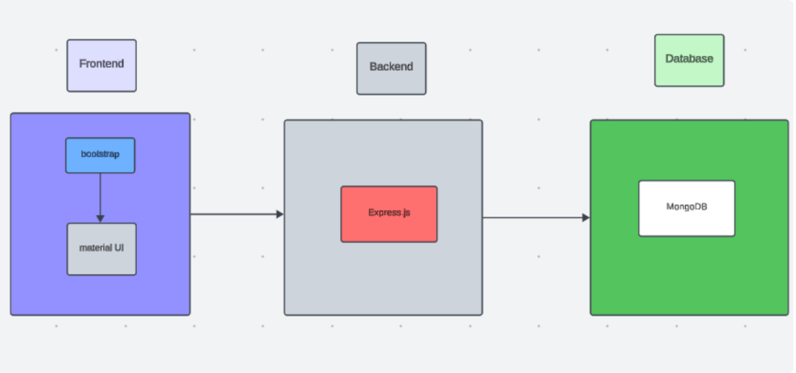

Technical Architecture Overview
- Frontend Layer
The frontend is developed using React.js.
      - Public Home page
      - User registration
      - User login
      - Agent login
      - Admin login
      - User dashboard
      - Complaint registration
- Backend Layer
The backend is developed using Node.js and Express.js.
      - Authentication
      - Authorization
      - User registration
      - Login
      - Complaint creation
      - Complaint retrieval
      - Agent assignment
      - Complaint status updates

ER DIAGRAM:
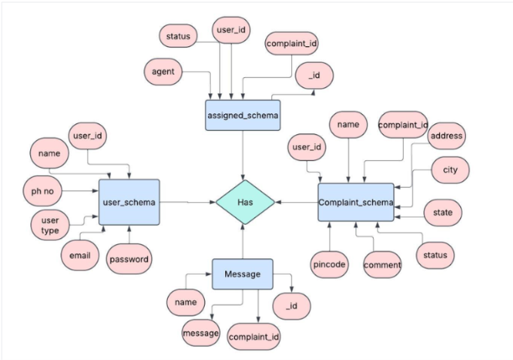

Entities and Relationships

1. User

Represents users, agents, and administrators using the system.

Stores details such as name, email, phone, password, and role.

Relationship: Submits → Complaint

2. Complaint

Represents complaints registered by users.

Stores details such as address, subject, description, status, and complaint ID.

Relationships: Belongs to → User; Assigned to → Agent; Has → Messages

3. Assignment

Represents the assignment of complaints to agents.

Stores complaint, user, agent, and assignment status details.

Relationship: Connects → Complaint and Agent

4. Message

Represents chat messages related to a complaint.

Stores complaint, sender, message, and timestamp details.

Relationship: Belongs to → Complaint

Key Features:
1. USER REGISTRATION & PROFILE CREATION
SECURE SIGN-UP: Users can register using email and password with secure authentication protocols.
PROFILE CREATION: Stores user details including name, contact info, and ID details for future complaint tracking.
2. OFFICER BROWSING & COMPLAINT TYPE FILTERING
SEARCH AND FILTER OFFICERS: Users can filter complaint categories or departments (e.g., Police, Electricity, Municipality).
REAL-TIME STATUS TRACKING: Users can view officer availability or the live status of complaints (e.g., Pending, In Progress, Resolved).
3. COMPLAINT LODGING & MANAGEMENT
EASY COMPLAINT FORM: Users lodge complaints by selecting category, writing a description, attaching documents/images.
AUTOMATED UPDATES: Email/SMS notifications sent for submission, updates, and resolution to keep users informed.
4. OFFICER’S DASHBOARD
MANAGE ASSIGNED COMPLAINTS: Officers can see, filter, and update complaints assigned to them.
ACTION LOGGING: Officers can add status updates, action notes, and attach resolution reports securely.
5. ADMIN CONTROLS & VERIFICATION
OFFICER APPROVAL SYSTEM: Admins verify and approve officer accounts to maintain system integrity.
SYSTEM MONITORING: Admin has access to analytics, can resolve disputes, handle escalations, and maintain platform security.

ROLES AND RESPONSIBILITIES:

1. USER REGISTRATION
Example:
Ravi, a citizen who wants to report a water leakage issue, visits the Online Complaint Portal. He registers as a user by providing his email, phone number, and password to create a secure account. Once registration is successful, he logs in and is greeted with a clean dashboard to begin.
2. BROWSING DEPARTMENTS & COMPLAINT TYPES
Example:
Ravi browses through various departments—such as Municipal Corporation, Electricity, Police—and filters based on category, location, and urgency level. He selects Municipal Department → Water Leakage.
3. LODGING A COMPLAINT
Example:
Ravi clicks on “Lodge Complaint,” selects the appropriate category, fills in the issue details, and uploads an image showing the leak. Once submitted, he gets a confirmation that the complaint has been received and is under review.
4. COMPLAINT CONFIRMATION
Example:
A concerned officer from the municipal department reviews Ravi’s submission and assigns it to a field technician. Ravi receives a notification via email/SMS that his complaint has been accepted and assigned with a tracking number.
5. USER COMPLAINT MANAGEMENT
Example:
Ravi can view the status of all his complaints on the dashboard—Pending, In Progress, or Resolved. He can also edit, cancel, or reopen a complaint if necessary, and communicate with the assigned officer.
6. ADMIN APPROVAL (BACKGROUND PROCESS)
Example:
An admin in the backend reviews and approves officer accounts and departmental access to ensure only verified officials are part of the platform. The admin also monitors misuse or spam complaints.
7. PLATFORM GOVERNANCE
Example:
The admin oversees overall platform activity, addresses escalated issues, handles user or officer disputes, enforces policies, and ensures data security and privacy compliance.
8. OFFICER'S DASHBOARD & TASK MANAGEMENT
Example:
The assigned officer logs into the dashboard, views the complaint details, and updates the complaint status (e.g., "Technician Assigned", "Work Started", "Resolved"). Officers can also provide notes, attach images, or request additional info.
9. FIELD VISIT & COMPLAINT RESOLUTION
Example:
A technician visits the location, fixes the leak, and updates the status in the system as Resolved. Officer uploads photos of the resolved issue for confirmation.

User Flow:

Customer/Ordinary User:
Role: Create and manage complaints, interact with agents, and manage profile information.
Flow:

Registration and Login:
Create an account by providing the necessary information such as email and password.
Log in using the registered credentials.
Complaint Submission:
Fill out the complaint form with details of the issue, including description, contact information, and relevant attachments.
Submit the complaint for processing.
Status Tracking:
View the status of submitted complaints in the dashboard or status section.
Receive real-time updates on the progress of complaints.
Interaction with Agents:
Connect with assigned agents directly using the built-in messaging feature.
Discuss complaints further and provide additional information or clarification.
Profile Management:
Manage personal profile information, including details and addresses.

Agent:
Role: Manage complaints assigned by the admin, communicate with customers, and update complaint statuses.
Flow:

Registration and Login:
Create an account using email and password.
Log in using the registered credentials.
Complaint Management:
Access the dashboard to view and manage complaints assigned by the admin.
Communicate with customers regarding their complaints through the chat window.

Status Update:
Change the status of complaints based on resolution or progress.
Provide updates to customers regarding the status of their complaints.
Customer Interaction:
Respond to inquiries, resolve issues, and address feedback from customers.

Admin:

Role: Oversee the overall operation of the complaint registration platform, manage complaints, users, and agents, and enforce platform policies.

Management and Monitoring:
Monitor and moderate all complaints submitted by users.
Assign complaints to agents based on workload and expertise

Complaint Assignment:
Assign complaints to the desired agents for resolution.
Ensure timely and efficient handling of complaints.
User and Agent Management:
Manage user and agent accounts, including registration, login, and profile information.
Enforce platform policies, terms of service, and privacy regulations.

Continuous Improvement:
Implement measures to improve the platform's functionality, user experience, and security measures.
Address any issues or concerns raised by users or agents for better service delivery.

MVC PATTERN:

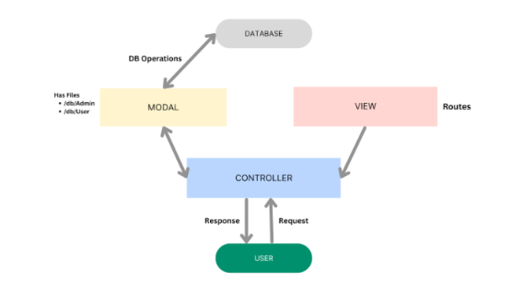

The complaint backend application follows the Model-View-Controller (MVC) architectural pattern, a software design approach that separates an application into three inter connected layers. This separation allows for modularity, easier maintenance, and scalability.
Model Layer (Data Layer)
The Model layer is responsible for handling all data-related logic. This includes the definition of data schemas and the operations performed on the database using those schemas. The models are implemented using Mongoose, which provides a schema-based solution to model application data for MongoDB.
Controller Layer
The Controller layer acts as an intermediary between the view (routes) and the model. It receives incoming requests, processes the input (which may include validation or transformation), calls the appropriate methods from the model, and then returns a response to the client.

View Layer (Routing Layer)
In the context of a backend REST API, the View is implemented as the routing layer, where various endpoints are defined. These endpoints determine how the backend responds to different HTTP requests (GET, POST, PUT, DELETE) and are responsible for invoking the appropriate controller functions.

Advantages of Using MVC in This Project
Separation of Concerns: Each layer has a clearly defined responsibility, improving readability and maintainability.
Scalability: New features can be added easily by creating new routes, controllers, and models.
Reusability: Logic in controllers and models can be reused across multiple parts of the application.
Testing: Each layer can be tested independently, especially the controllers and models.
Collaboration-Friendly: Multiple developers can work simultaneously on different layers without conf

Project Setup And Configuration.

- Create the project with Frontend and Backend folders.
- Frontend: React.js with Vite, Axios, React Router, Bootstrap and React Toastify.
- Backend: Node.js with Express.js and required dependencies.
- Configure MongoDB using .env.
- Create folders for models, controllers, routes, middleware, and config.
- Run frontend and backend using Vite and Nodemon.

BACKEND DEVELOPMENT:

Developed the backend using Node.js and Express.js.

Implemented JWT authentication and role-based authorization.

Created REST APIs for users, complaints, assignments, and messages.

Added input validation, error handling, security middleware, and request logging.

Connected the backend with MongoDB using Mongoose.

Backend Structure:
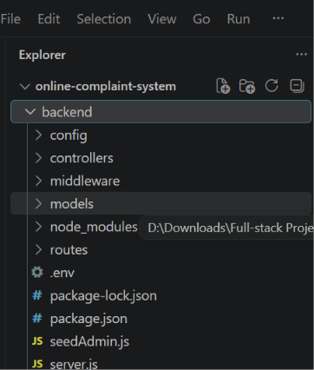

Backend/
- config/ – Contains database configuration such as MongoDB connection.
- controllers/ – Contains business logic for authentication, complaints, assignments, messages, and admin operations.
- middleware/ – Handles authentication, authorization, validation, error handling, and logging.
- models/ – Defines MongoDB schemas such as User, Complaint, Assignment, and Message.
- routes/ – Defines REST API endpoints for different modules.
- .env – Stores configuration and sensitive environment variables.
- seedAdmin.js – Creates the initial admin account.
- server.js – Main entry point that configures Express, middleware, routes, and starts the server.
- package.json – Contains project dependencies and scripts.

DATABASE DEVELOPMENT:
Install Mongoose
In your Node.js project directory, run:
npm install mongoose

Imports Mongoose, which provides schema-based modeling and convenient MongoDB
operations in Node.js.
Declares a function called connectToDB. This will be called in your main server file (server.js or app.js) to initiate the DB connection.

Connects to MongoDB using the connection URI stored in process.env.MONGO_DB.
The second argument is an options object:
useNewUrlParser: true ensures the new MongoDB connection string parser is used.
useUnifiedTopology: true uses the new Server Discovery and Monitoring engine, which handles replica sets and sharding better.

If the connection is successful, it logs a confirmation message.
If the connection fails, it throws an error with a message.
It’s a good practice to handle this error gracefully instead of just throwing it. You could console.error() and exit the process using process.exit(1) if needed.
Exports the connectToDB function so it can be used in other files, like your server.js:

FRONT-END DEVELOPMENT:

Frontend Structure:

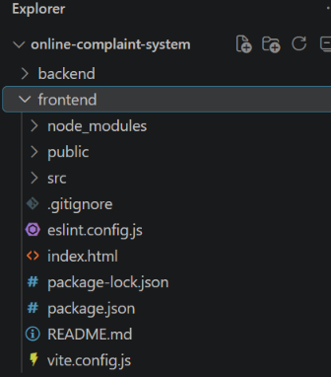

Frontend/
- public/ – Stores static files such as images.
- src/ – Contains the main React application code and components.
- node_modules/ – Contains installed project dependencies.
- package.json – Contains dependencies and project scripts.
- vite.config.js – Vite configuration file.
- eslint.config.js – ESLint configuration for code quality.
- index.html – Main HTML entry file.
- README.md – Project information and instructions.
- .gitignore – Specifies files ignored by Git.

Output ScreenShots: Home Page :
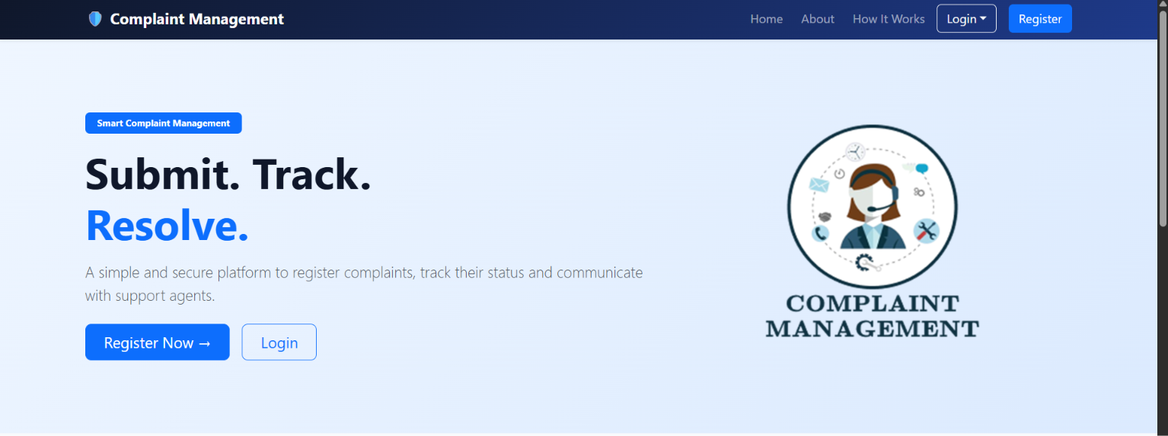

Admin Dashbord:

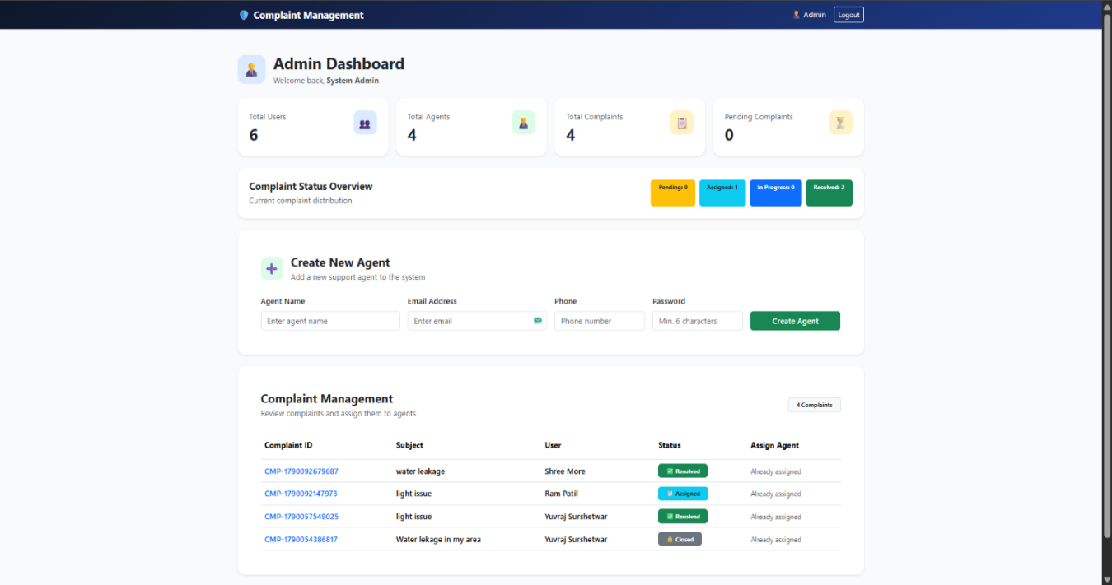

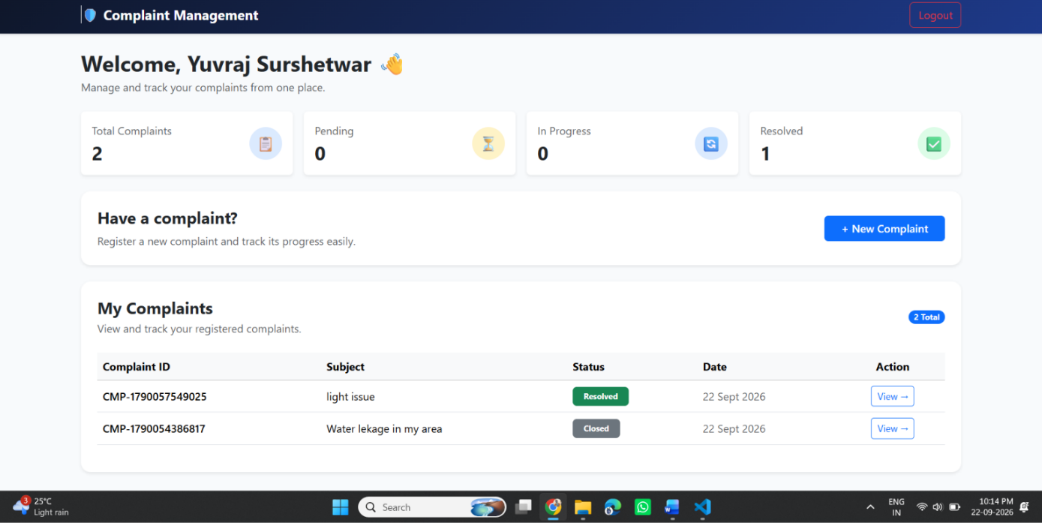
User Dashbord:

Agent Dashbord:
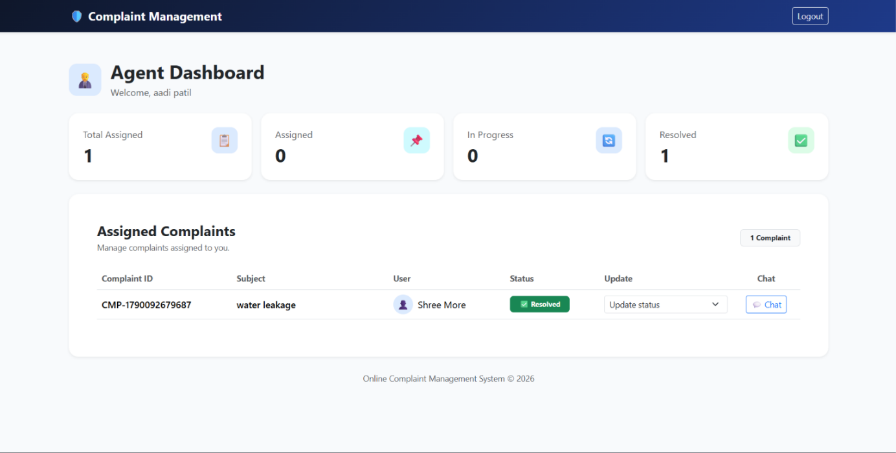

Demo Video Link: Demo video
Code Drive Link: code

